COFFEE VENDING

MACHINE

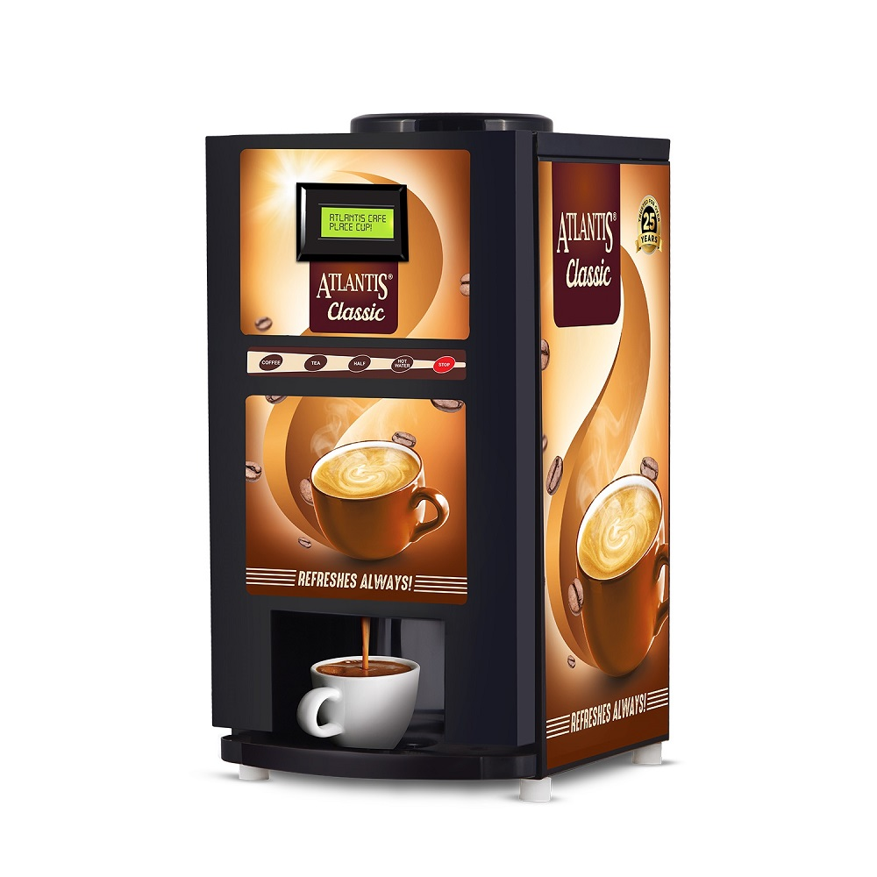BY

YASHWANTH KR-221EC264

RAGHAVENDRA Y-221EC262

INTRODUCTION

* Coffee vending machine is a machine that dispenses the coffee as a product to the customers automatically after the customer insert the currency
* Large-scale retailing is possible by keeping the coffee vending machines in the convenient places such as near the companies
* The buyer inserts the currency and receives the specific amount of the coffee
* This helps for 24 hours of service in a day
* Reduces the labour requirement

ASSUMPTIONS

* Cost per coffee is 20 rupees
* Coffee vending machine will take inputs of 5rs,10rs,15rs and 20rs as 00,01,10,11
* If the inserted money is more than 20rs then the coffee vending machine will return the extra amount
* Coffee vending machine will return the change 5rs,10rs and 15rs as 01,10 and 11 as the output

STATE TABLE

|  |  |  |  |  |  |  |  |  |  |
| --- | --- | --- | --- | --- | --- | --- | --- | --- | --- |
| PRESENT  STATE | | Input  money | | Next  state | | coffee | | balance | |
| A | | 00 | | B | | 0 | | 00 | |
| A | | 01 | | C | | 0 | | 00 | |
| A | | 10 | | D | | 0 | | 00 | |
| A | | 11 | | A | | 1 | | 00 | |
| B | | 00 | | C | | 0 | | 00 | |
| B | | 01 | | D | | 0 | | 00 | |
| B | | 10 | | A | | 1 | | 01 | |
| B | | 11 | | A | | 1 | | 10 | |
| C | | 00 | | D | | 0 | | 00 | |
| C | | 01 | | A | | 1 | | 00 | |
| C | | 10 | | A | | 1 | | 01 | |
| C | | 11 | | A | | 1 | | 10 | |
| D | | 00 | | A | | 1 | | 00 | |
| D | | 01 | | A | | 1 | | 01 | |
| D | | 10 | | A | | 1 | | 10 | |
| D | 11 | | A | | 1 | | 11 | |

STATE DIAGRAM

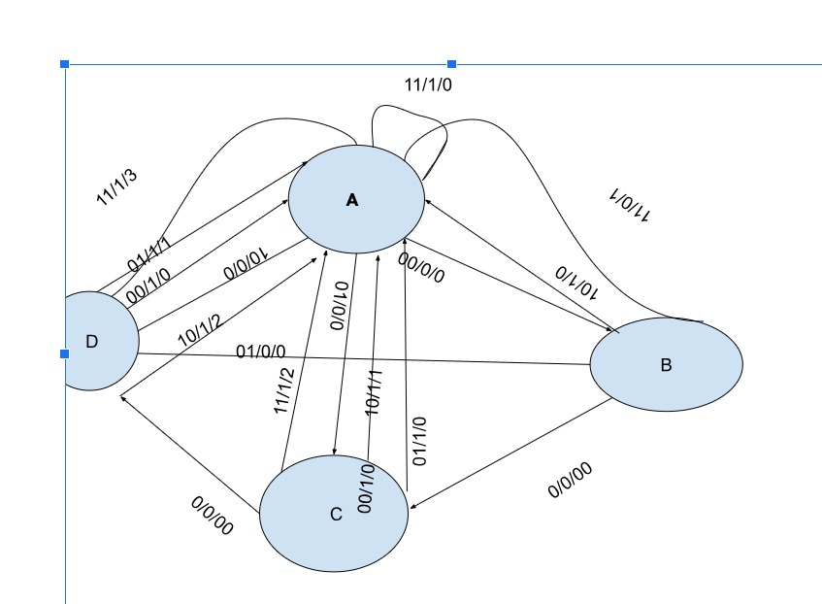

CODE

module main(

input clk,

input rst,

input [1:0] money,

output reg cof,

output reg [1:0] bal

);

reg [2:0] pr;

reg [2:0] nx;

parameter A=2'b00;

parameter B=2'b01;

parameter C=2'b10;

parameter D=2'b11;

always @(posedge clk)

begin

case(pr)

A: if(money == 2'b00)

begin

nx = B;

cof = 1'b0;

bal = 2'b00;

end

else if(money == 2'b01)

begin

nx = C;

cof = 1'b0;

bal = 2'b00;

end

else if(money == 2'b10)

begin

nx = D;

cof = 1'b0;

bal = 2'b00;

end

else if(money == 2'b11)

begin

nx =A;

cof= 1'b1;

bal = 2'b00;

end

B: if(money == 2'b00)

begin

nx=C;

cof= 1'b0;

bal = 2'b00;

end

else if(money == 2'b01)

begin

nx=D;

cof = 1'b0;

bal = 2'b00;

end

else if(money == 2'b10)

begin

nx=A;

cof = 1'b1;

bal = 2'b00;

end

else if(money == 2'b11)

begin

nx=A;

cof = 1'b1;

bal = 2'b01;

end

C: if(money == 2'b00)

begin

nx = A;

cof = 1'b0;

bal = 2'b00;

end

else if(money == 2'b01)

begin

nx = A;

cof = 1'b01;

bal = 2'b00;

end

else if(money == 2'b10)

begin

nx = A;

cof = 1'b1;

bal = 2'b01;

end

else if(money == 2'b11)

begin

nx = A;

cof = 1'b1;

bal = 2'b10;

end

D: if(money == 2'b00)

begin

nx = A;

cof = 1'b1;

bal = 2'b00;

end

else if(money == 2'b01)

begin

nx = A;

cof= 1'b1;

bal = 2'b01;

end

else if(money == 2'b10)

begin

nx = A;

cof= 1'b1;

bal = 2'b10;

end

else if(money == 2'b11)

begin

nx = A;

cof = 1'b1;

bal = 2'b11;

end

default: nx = A;

endcase

end

always @ (posedge clk or posedge rst)

begin

if(rst)begin

pr <= A;

nx<=A;

end

else

pr <= nx;

end

endmodule

TESTBENCH

module tb_main(

);

reg clk;

reg rst;

reg [1:0] money;

wire cof;

wire [1:0] bal;

main dut( clk, rst, money, cof, bal);

initial clk=1'b0;

always

begin

#50 clk = ~clk;

end

initial

begin

rst = 1'b1;

#50 rst = 1'b0;

money = 2'b00;

#100 money = 2'b01;

#100 money = 2'b10;

#100 money = 2'b00;

#100 money = 2'b11;

#100 money = 2'b11;

#100

$finish;

end

endmodule

WAVEFORM

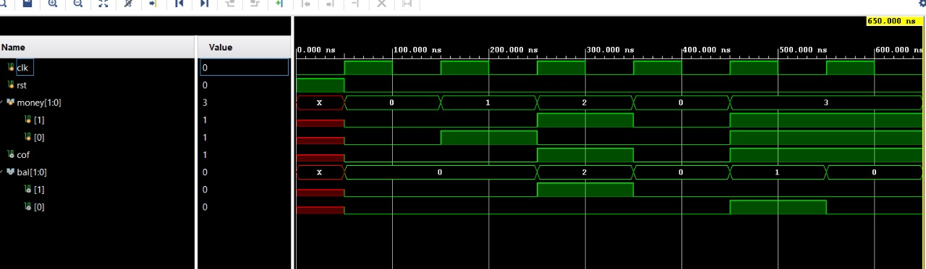

CONCLUSION

* The goal of this project was to develop a most effective automatic coffee vending machine

REFERENCES

* <https://en.wikipedia.org/wiki/Coffee_vending_machine#Concept_machines>
* <https://stackoverflow.com/questions/40526848/coffee-vending-machine-simulation-with-testbench-issue>